**EE475 Home Project Regulations**

1. You must do your homework individually. Any evidence of copying from each other or plagiarism will invalidate your work. You can, of course, discuss the problem with your classmates, consult the instructor and/or the course assistant. But in the end it must be your own work.
2. It is important that you organize the page layout of your homework to be as aesthetic, presentable and as compact possible. I suggest that you choose to use the IEEE paper format as attached.
3. Your answers to questions will consist of i) images, figures, graphics; ii) commentaries and explanations about the results. Commentaries and explanations are musts.
4. Zip your document with your source code (.m files) and email it to [ee475boun@gmail.com](mailto:ee475boun@gmail.com). Make sure your code works when you send it. The zip file should also include a "readme" file that explains how to reproduce your results.
5. Bring a printed copy of your homework on due date to the class.

**EE475 Fall’19**

**Homework 1**

**Generating image patterns**

We will often need to generate image synthetic patterns to execute various image processing algorithms such as de-noising, high-pass filtering etc. a. Since the ground-truth is known we can exactly measure the performance. Generate an image composed of two concentric circles as shown below. The inner circle should have a radius of 64 pixels and a mean value of 192. The outer circle should have a radius of 128 pixels and a mean value of 128. The background should have a mean value of 64. Add uniform random noise to each pixel of the inner circle in the range -16 .. +16 (see Matlab’s randfunction) and to each pixel of the outer circle in the range of – 42 … +42. Save the image in “tif” format, and make sure the saved image looks correct. Turn in the Matlab program and the image that you generated. On the borders of the circle: x2 + y2 = r2 choose the inner circle gray level.



**IMAGE READ & WRITEs; HISTOGRAM PLOTs:**

Read ”fish.bmp”, store it in an array I and display the image. Use the imwrite function and write the array I to a disk file with the filename extension ”.png”. Use the iminfo function to see the contents of the written file.

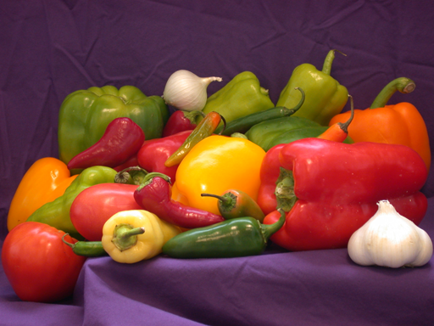

a) Extract R, G, B color components of ”fish.bmp” and display (plot) separately each component.

b) Find the spatial locations (x,y) of the pixels having the following R,G,B color values: R>90, G>10, B<40. Create a new binary matrix (image) that has 1 in the corresponding spatial locations, otherwise 0. Display the binary image and comment on the result. (1 should be plotted as 255, and 0 as 0; or vice versa)

c) Create a new image named ”gray.bmp” by taking the average of the color components (R + G + B)/3 and display it.

d) Use the imhist function and plot the histogram of ”gray.bmp”. Comment on the plot: what are the x- and y-axis? Are there definite peaks? Does the histogram occupy the whole gray level range?

e) Divide all the gray-scale pixel values of ”gray.bmp” by 2 and display the resulting image and its histogram. Comment on the results. Add 64 to all gray levels (any value exceeding 255 should be truncated to 255) and plot its histogram. Comment on the results.

**PIXELS VARIETIES**

Consider the images below:

* 1. If the object is self-luminous, as in the Cetus galaxy (actually, a small galaxy in the constellation Cetus, contains 200 million suns' worth of stars**)**, what are the approximate coordinates of the point that emits the most amount of light?
  2. If the image is taken with a range camera, as in the Office image, what are the approximate coordinates of the closest point and the farthest points?
  3. If the image represents material density, as in the Breast and Skull images, what are the approximate coordinates of the opaquest (densest) and least opaque (most transparent) points with the Region of Interest (RoI)?
  4. If the image is captured with a thermal camera, where are the hottest points?
  5. In the sequence of three images from Hamburg Taxi sequence, where are the fastest changing points?

|  |  |
| --- | --- |
| C:\Users\Busim-DellT5600\Downloads\head24.tif  Skull | C:\Users\Bulent Sankur\Documents\DROP_475_2016\EE475_Image_Data\Depth Images\Breast_density.jpg  Breast |
| C:\Users\Bulent Sankur\Documents\DROP_475_2016\EE475_Image_Data\Depth Images\DEPTH_tnnr.png  Office | C:\Users\Bulent Sankur\Dropbox\DROP_EE475_2018\HW_Basics\Cetus_NGC1052Galaxy.jpg  Galaxy |
| C:\Users\Bulent Sankur\Dropbox\DROP_EE475_2018\HW_Basics\Thermal_pedestrian_00014.bmpThermal | http://i21www.ira.uka.de/image_sequences/pics/taxi.gif |

**IMAGING SYSTEM DESIGN**

A pool-playing robot uses an overhead camera to determine the positions of the balls on the pool table. Assume that: a) We are using a standard billiard table of size 150x280. b) We need at least 100 square pixels per ball to reliably determine the identity of each ball; the ball diameter is 5.7 cm. c) The center of the ball can be located to a precision of +- one pixel in the image. d)We need to locate the ball on the table to an accuracy of +- one cm. e) We are going to mount the camera on the ceiling, looking straight down. The distance from the camera to the table is 2 m. Determine a configuration of the camera resolution and lens field of view (FOV) that will meet these requirements. Assume that you can choose from the following parts: Lenses with field of view 30, 60, 90 degrees. Cameras with resolutions of 256x256, 512x512, or 1024x1024 pixels. Choose the lowest camera resolution that will meet the requirements.

1. First determine the viewing angle needed. The camera is looking down from 2 m and most span 280 cm. Use tangent formula to field of view.
2. To determine the camera resolution, there are two criteria to be satisfied: a) The precision of 1 cm for the ball center; b) The requirement of having 100 pixels per ball. Check both conditions and take the larger of the two.